Sustainability Seen Through the Eyes of Children:
Sustainability Workshops for K-5 classrooms

1. INTRODUCTION

Education is important at all levels and for all ages. In order to positively impact our planet it is important to empower our younger generation with the knowledge and the tools necessary to actually make that very same impact. By bringing environmental issues to light in an interactive, fun and informative way, we will be able to inspire children to become the champions for the environment. Our sustainability workshop series strives to create a domino effect of knowledge sharing. Our goal is for each child, student and participant to share what they learn during the workshop with their friends and families, thereby cultivating a culture of environmental leaders who will be ready to take immediate action against the urgent issue of climate change.

The sustainability workshop series is comprised of three main subjects: water, energy and waste. Each workshop is divided into two parts:
- Interactive presentation (45 minutes)
- Hands-on lab (45 minutes)
The content of each workshop and learning outcomes are detailed below.

2. WATER WORKSHOP

2.1. Water Workshop Presentation Content

California is in the midst of a water crisis. With a growing population, water demand has been rising at an astonishing rate for the last 20 years; however water supply has been dwindling. The significance of this dilemma is the impact that it will have on future generations if action is not taken. The water workshop is a means to convey the importance of this challenge.

The beginning of the workshop presentation focuses on the ephemeral and practical uses and benefits of water. The presentation focuses upon the notion that water provides us with fun, refreshment, and even electricity; however most importantly, water is defined as being precious and scarce.

Students will be surprised to find that only 3% of the Earth’s water is actually drinkable. However students will be even more mystified by the fact that only 1% of that 3% is actually accessible water, while the remaining 99% is frozen in ice caps or glaciers. To further emphasize this point, students will be asked to stand. Three students will be asked to remain standing while the rest of the students are asked to take a seat. We will then explain that these three students represent all the water on Earth that is drinkable. Lastly, two students will be asked to stand, with only one student left standing. We then will explain that this one student represents all the drinkable water on Earth that we have access to. Students will at first be amused, but then surprised by the reality of our scarce water supply.
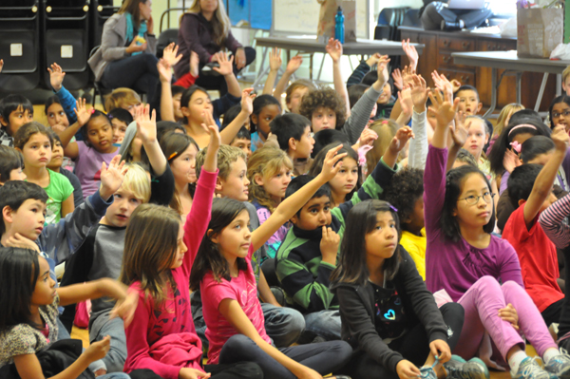
Fig. 1: Students participate in the water workshop question and answer session

2.2. Water Cycle Song

To help the students understand the science behind the water, the water cycle is introduced to the class in an interactive way. An animated diagram which illustrates the water cycle is provided. This is followed by an interactive “water cycle song.” Students are asked to stand and sing along to the following lyrics:
“Water travels in a cycle, yes it does.
Water travels in a cycle yes it does.
It forms clouds as condensation.
Comes down as precipitation.
And goes up as evaporation.
Yes it does.”
Students will be entertained with the notion that a science subject could become a song. However, the simplicity of the tune and the lyrics will ingrain the steps of the water cycle into each student’s memory.

2.3. Water Workshop Lab

The impact of water is detailed in terms of where it comes from and where it goes. This provides students with a better understanding of how their actions can impact the environment as a whole. The route of water is detailed from the sky, to the earth, to treatment facilities, and back to the ocean.
As the majority of our water in the U.S. is supplied by underground sources, the concept of groundwater conservation and pollution prevention is the major focus. To demonstrate the concept of groundwater, students assemble their own small scale aquifers. Students are asked to layer materials to form a cross section of a typical aquifer. Using plastic cups, the students create a sloped hillside of earth using the following materials layered from bottom to top: sand, gravel, and clay. They then pour in clear water to represent untainted groundwater. Finally they are asked to drop “toxins”, represented by pomegranate and blueberry juice, onto the clay. The students will observe as the pollutants slick off of the clay, and trickle into the gravel and sand, and eventually make their way to the water. They also will observe how the stain remains trapped deep within the sand. They will then record their observations down on paper, draw diagrams of their aquifers, and list ideas for how they could prevent water pollution. This exercise allows the students to visually understand the immediate and long terms effects of pollutants on land and in our water. Students will become aware that in order to have access to clean drinking water, they are charged with keeping their above ground environment clean and free of chemicals.
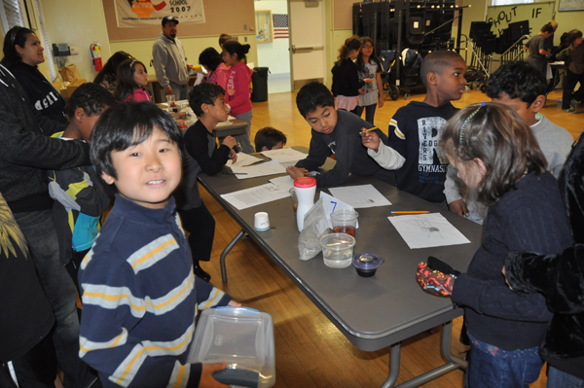
Fig. 2: Students build their own aquifers during the water workshop lab.

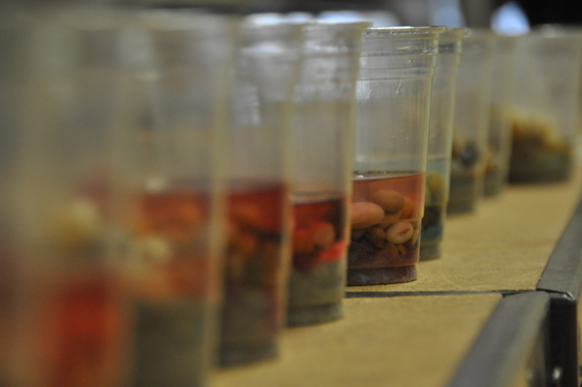
Fig.3: Sample aquifers showing ‘contaminated’ water from the water workshop lab.

3. ENERGY WORKSHOP

3.1. Energy Workshop Presentation Content

Energy consumption is one of the largest contributors to greenhouse gas emissions. In order to curb the effects of global warming, an emphasis on energy consumption is required. The energy workshop aims to teach students alternative ways to conserve, use and produce energy.

The energy workshop presentation focuses on both the conceptual nature as well as the very tangible aspects of energy. Energy is described as being all around us, as something that every living thing needs in order to function. The more tangible aspects of energy are then presented, including how energy is used to power our multiple electronic devices and cars. Students are then asked to draw what they think energy “looks like” on a piece of paper and then discuss their ideas with a partner.

3.2. Carbon Emissions and Energy

The effect of energy use on climate change is also discussed at length. To demystify the notion of what CO2 is, a short animation is shown which personifies pounds of CO2 falling from the sky. The students will find the animation humorous and informational, but at the same time they will understand the notion that carbon emissions can be detrimental to our livelihood in the end.

This notion of pounds of CO2 is then extended to a set of graphs used to illustrate the amount of emissions released into the atmosphere from various countries. The students will be astonished to learn that the U.S. has the most pounds per capita of emissions, when compared to all the other nations of the world. Students will have the opportunity to learn how energy is used in other parts of the world during this segment when they skype with a school in another part of the world. They will have a chance to discuss the concept of energy use with students a continent away, which will be both enlightening and exciting.
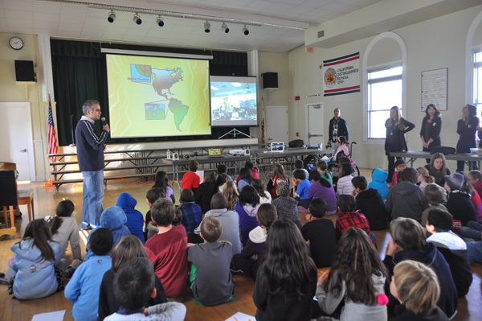
Fig. 4: Students communicate with students from Venezuela during the energy workshop.

3.2. Energy Workshop Lab

To demonstrate the concepts of energy introduced during the presentation half of the energy workshop, a solar cooker lab is conducted. Solar cookers are an ideal method of showcasing how the sun could be used in an efficient way to provide a ‘free’ source of energy to conduct activities for everyday life. The students will break into small groups and work to create snacks such as s’mores, chocolate covered strawberries, quesadillas, and cheese and crackers. Students will record their observations down on paper. The lab is highly interactive, fun and educational.
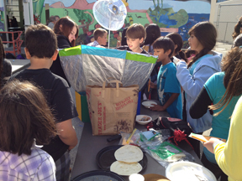
Fig. 5: Students work together to build and use solar cookers.

4. WASTE WORKSHOP

4.1. Waste Workshop Presentation Content

The workshop series culminates in the third and final workshop which focuses on waste. Waste is defined to the students as something that is used carelessly. To tie the three workshops together, waste is also defined as not simply being limited to ‘trash’, but which also applies to wastefulness of water and energy.

The students are introduced to a series of statistics about waste which prove to be illuminating. They will be surprised to learn that The U.S. makes up only 5% of the population on the planet, yet consumes 30% of all the resources and produces 30% of all the waste, which equates to approximately 7 pounds of waste per person, per day. Furthermore, they will learn that garbage production in the U.S. has doubled over the last 30 years.

Students also will learn about current waste management practices such as landfills and incinerators. Diagrams will be provided which detail how a landfill is used. Students will discover how waste housed within landfills can often seep into the surrounding environment, thereby polluting our soil, water, and even our air.

To combat the issue of waste, the presentation also focuses on tactics that the students could employ at home or at school. These include the familiar mantra of: reduce, reuse, and recycle, but also include ‘new’ tactics such as sharing material possessions rather than buying new ones and composting food waste.

4.2. Waste Workshop Lab

To demonstrate waste management tactics introduced during the presentation, a “waste busters” lab is conducted. The students work in small teams. Each team receives a bag of ‘trash’. Students are asked to sort the trash and eliminate or salvage as much as possible using the methods they learn about. Points are allotted for each method of waste management. These include:
- Reuse: 10 Points
- Recycle: 3 Points
- Compost: 8 Points
- Share: 10 Points
- Dispose in trash if required: 0 points
- Dispose in trash even though it is not required: -2 points
The team with the most number of points will win the game. Students are then challenged to create new things out of the salvaged trash. Creations could range from art work to a full ensemble of musical instruments. Students will have fun and learn from these hands-on activities while learning about how to rethink the notion of waste.
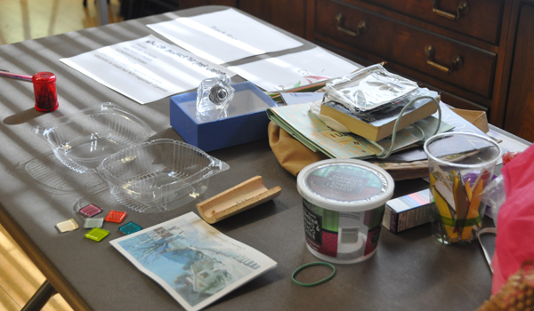
Fig. 6: Materials used for the waste busters lab.

5. Continuing Education

5.1. A Children’s Book

To broaden the reach and purpose of the workshops, our team decided to develop the series into an educational book, titled “Sustainability Seen through the Eyes of Children.” Working with the graphic artist who helped to create the characters for the workshop, the three subjects will be woven together through an illustrated storyline. The book is intended to be provided in both hardcopy and electronic copy for teachers, students and parents to use at home or at school. The appendix will include directions for each of the three subject labs. 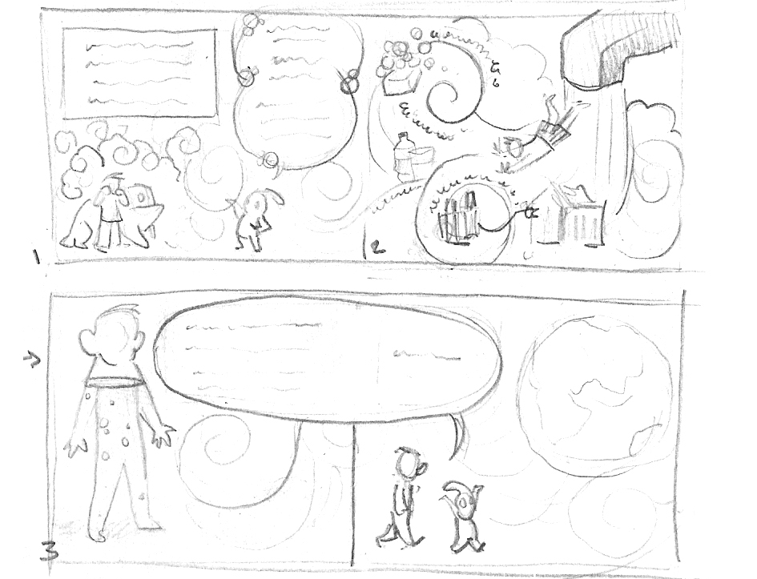
Fig. 7: Cartoon sketches of the forthcoming book, titled “Sustainability as Seen through the Eyes of Children”.
5.2. Working with the USGBC

In 2012, these Sustainability Workshops received the first USGBC (U.S. Green Building Council) Impact Award. The USGBC is currently working with our team to develop the workshop presentations into a template which would become available on the USGBC outreach website. In this way, the workshops will become an educational resource with an unlimited scope, reaching numerous environmental stewards and educators around the globe.
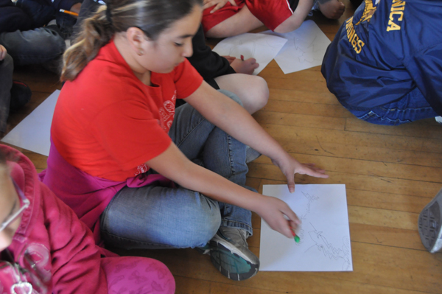
Fig. 8: Student sketch of what energy “looks like”.

6. CONCLUSION

These sustainability workshops will provide students with a worldview perspective of the environmental issues, thereby increasing their awareness and giving them practical suggestions on how they, as elementary school children, can build a better planet for all. The workshops will transmit respect, love and knowledge of and for the environment. The knowledge in turn will empower them to take on the charge of our future environmental champions.

